**Tutorial 7**

**The continuity of function.**

**Continuity of function**

We are given a function  . One-sided limits of function  are defined by  Thus, left-hand limit as $x$ approaches *c* from the left is:

=; (1)

and right-hand limit as $x$ approaches *c* from the right is:

 =. (2)

If a function  is continuous at a point  then

=  (3)

If equality (3) does not hold then  is a point of discontinuity. Namely, if there are  and but

, (4)

then  is called a *discontinuity of the first kind* (jump),

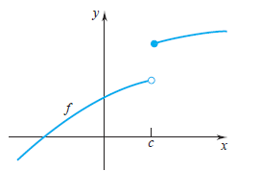

jump= $\left|-\right|$;

If

, (5)

then  is called *discontinuity* *of the first kind* (*removable* *discontinuity*).

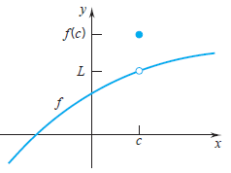

For continuity of a function  at a point , it is *necessary and sufficient*  that

= (6)

Discontinuities of a function that are not of the first kind are called *discontinuities of the second kind*. Infinity discontinuities also belong to discontinuities of the second kind.

If one of the limits  and  approaches  then  is a point of discontinuity (second kind).

**Example.** The functions at the point $x=0$ has a discontinuity of the second kind, since both one-sided limits are nonexistent here:



**Example.** Forfunctions and  find:

а) points of discontinuity;

b) one-sided limits at a point of discontinuity;

c) classify the points of discontinuity.

**Solution:**

1) .

а) The function is not defined at х= - 6. A point х= - 6 is a point of discontinuity;

b) the one-sided limits of this function are equal:

= 0,

= $∞;$

c) Since right-hand limit equals to , consequently , х= -6 is a point of discontinuity (second kind).

2)  .

а) х=3 is a point of discontinuity;

b) the one-sided limits of this function are

= -,

=+;

c) We already know that infinity discontinuities belong to discontinuities of the second kind, so х=3 is a point of discontinuity (second kind).

**Example.** Determine the discontinuities, if any, of the following function:



**Solution**: Clearly *f* is continuous at each point in the open intervals

(−∞*,* 0)*,* (0*,* 1)*,* (1*,*∞). (On each of these intervals *f* is a polynomial.)

Thus, we have to check the behavior of *f* at *x* = 0 and *x* = 1.

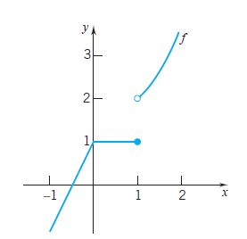

If we construct the graph of this function then we can see that *f* is continuous at 0 and discontinuous at 1. Indeed, that is the case:

*f* (0) = 1*,*



This makes *f* continuous at 0.

The situation is different at *x* = 1:



Thus, *f* has an essential discontinuity at $x=1,$ a jump discontinuity.

**Example.** Determine the discontinuities, if any, of the following function:



**Solution**: Clearly *f* is continuous at each point in the open intervals

(0;1)*,* (1;2,5)*,* (2,5;+∞). Thus, we have to check the behavior of *f* at *x* = 1 and *x* = 2,5.

One-sided limits of function at *x* = 1 are

=2; = 2

and the value of this function at *x* = 1 is

.

Since



then the function *f* is continuous at point *x* = 1.

One-sided limits of function at *x* = 2,5 are

= -1;  - 2

and the value of this function at point *x* = 2,5 is

.

Since



then the function *f*  is not continuous at point *x* = 2,5.

Thus, *f* has an essential discontinuity at 2,5, a jump discontinuity.

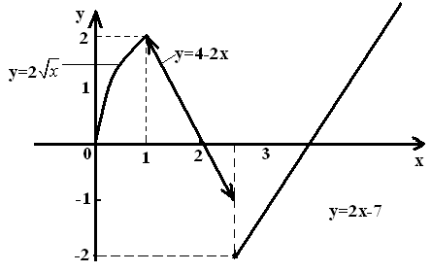

**Example.** The function $y=cos\frac{π}{x}$ at the point x=0 has a discontinuity of the second kind, since both one-sided limits are nonexistent here

